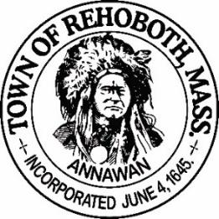

REHOBOTH TOWN EVENTS COMMITTEE

Meeting Minutes

Location: Francis Farm, 27 Francis Farm Rd, Rehoboth, MA
Date: June 14, 2022 at 7:00pm

Attendance: David LeComte, Jennifer LeComte and Kelli Trexler

Absent: Odete Lacourse, Sheila Kramer and Regan Furtado

This is an unofficial meeting due to a lack of quorum.

Agenda Items:

Recruitment: We need to get some more active members for the committee.
Clam Bake: Mike Deignan (BOS) says we need to have all our ducks in a row before we approach the Board. Dave has spoken to Linda Sherman at the COA and she is okay with the idea. Kevin Foley is on board to do the cooking along with Chico Charbonneau. Chico has the Serve Safe Certification that will be required. Dave presented to ideas to George Solas (BOS) and he will get us on the agenda next week for the BOS meeting.
Ideas discussed:
Music: something like Donnelly & Carmichael.
Date: August 13 versus 20th
Tickets: $35 each, sell through Eventbrite, presell only, 12 and under $25, We will check with Kevin Foley about capacity and what he is comfortable cooking for.
ETOH: not allowed on the premises. Question if we could have a third party insured vendor for ETOH.
Flower Arranging Class: Jen reached out to Designs by Sheila. She can do a class in a tent outside of her shop. She has us on the schedule for July 17th with a rain date of July 31st. Time 9-11:30 ish. We will budget for $30-$35 per person and they will all leave with a nice arrangement. The theme will be an English Tea Party. She is insured. We will need to get tables and chairs and provide the food and beverages. I was thinking Mimosas and Bellinis and lite fare like pastries and/or finger sandwiches and cookies. Any ideas? I will start working on a flier for this. I will need help with the event so please mark your calendar now.
Social Media: The town still has not developed a social media policy. Dave has inquired again about the policy.
Finance: No update at this time
Next Meeting: July 5th, 7:00 pm at the Francis Farm Arcade building.

Respectfully submitted,

Jennifer Lecomte
Clerk – Town of Rehoboth Events Committee

Meeting Minutes Approved (date and time):

Date: _08-07-2022_____ Time: ____________

Signature of The Town Event Committee Chairman
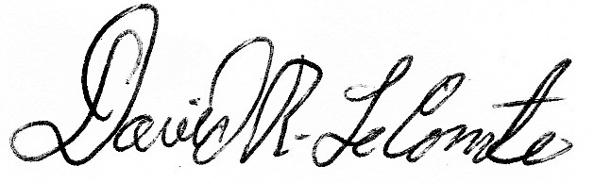
after minutes have been approved:

________________________________________
David LeComte – Chairman

